Regulations:
A18

H.T No

Sreenidhi Institute of Science and Technology
(An Autonomous Institution)
Code No: 7AC02 Date: 24-June-2019 (AN)

B.Tech I-Year I-Semester External Examination, June-2019 (Supplementary)
NETWORK ANALYSIS (ECE)

Time: 3 Hours Max.Marks:70

Note: a) No additional answer sheets will be provided.
b) All sub-parts of a question must be answered at one place only, otherwise it will not be valued.
c) Missing data can be assumed suitably.

Part - A Max.Marks:20

Answer all QUESTIONS.

1. | Explain independent and dependent sources with example . | [2M]
2. | Define and explain Peak factor. | [2M]
3. | Compare Electric and magnetic circuits. | [2M]
4. | Explain the importance of Maximum power transfer theorem. | [2M]
5. | Convert Z-parameters into Y-parameters of a two port network. | [2M]
6. | Explain the transient response of series RC circuit for sinusoidal excitation. | [2M]
7. | Define and explain resonance frequency of series RLC resonance circuit. | [2M]
8. | Explain the concept of mutual inductance. | [2M]
9. | Write the condition for reciprocity and symmetry of a two port network. | [2M]
10. | State and explain reciprocity theorem. | [2M]
Part – B Max.Marks:50
ANSWER ANY FIVE QUESTIONS. EACH QUESTION CARRIES 10 MARKS.

11. | a) | Using mesh analysis, find the current through 8Ω resistor of a circuit shown in figure1.  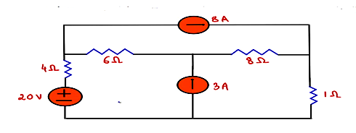  figure.1 | [5M]
 | b) | Find the necessary equations for delta to star conversion. | [5M]
12. | a) | Derive the expressions for the bandwidth of parallel resonating circuit and obtain its relationship with Q-factor. | [5M]
 | b) | Determine the average and effective values of saw-tooth waveform shown in Figure 2.  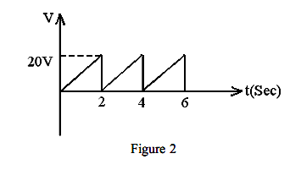 | [5M]
13. | a) | Derive the relation between self-inductance, mutual inductance and coefficient of coupling. | [5M]
 | b) | State and explain Faraday’s laws of electromagnetic induction. | [5M]
14. | a) | Find the current in the 10Ω resistor for the circuit shown in figure.3 using superposition theorem.  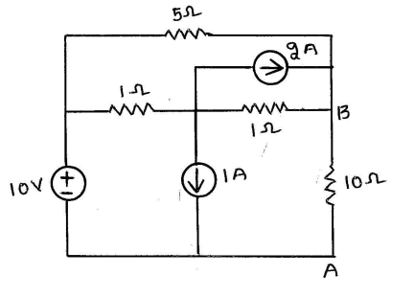  Figure.3 | [5M]
 | b) | State and explain Thevenin’s theorem with an example. | [5M]
15. | a) | Determine Z-parameters of the network shown in figure.4  Figure.4 | [5M]
 | b) | Explain a two port network with h-parameters | [5M]
16. | a) | Find i(t) for t≥0 when the switch is moved from position 1 to 2 at t=0. The switch was in position 1 for a long time in the network shown in figure.5.  Figure.5 | [5M]
 | b) | Determine i(t) for all values of time of the circuit shown in Figure. 6  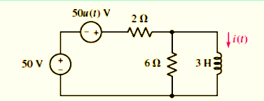  Figure.6 | [5M]
17. | a) | Explain the terms RMS value, average value and form factor for a periodic waveform. | [5M]
 | b) | Discuss the Source Transformation techniques . | [5M]
18. | a) | Find the transmission parameters of the network as shown in the figure.7.  Figure.7 | [5M]
 | b) | Explain the need of network theorems. | [5M]

-- 00 -- 00 –

